A BRIEF HISTORY
Alpha Lambda Delta was founded in 1924 by the Dean of Women, Maria Leonard, at the University of Illinois to recognize academic excellence among freshmen women.
At the first meeting of the chapter, Florence Finn, president of the society, presented a passage from Plato’s Republic in which Socrates asks the question, “Will they hold torches and pass them to one another...?” This idea, together with the symbol of a candle and the concept of sharing the love of learning with others, caught the imagination of the charter members.
ALPHA LAMBDA DELTA
COLLEGE/UNIVERSITY
INDUCTION CEREMONY

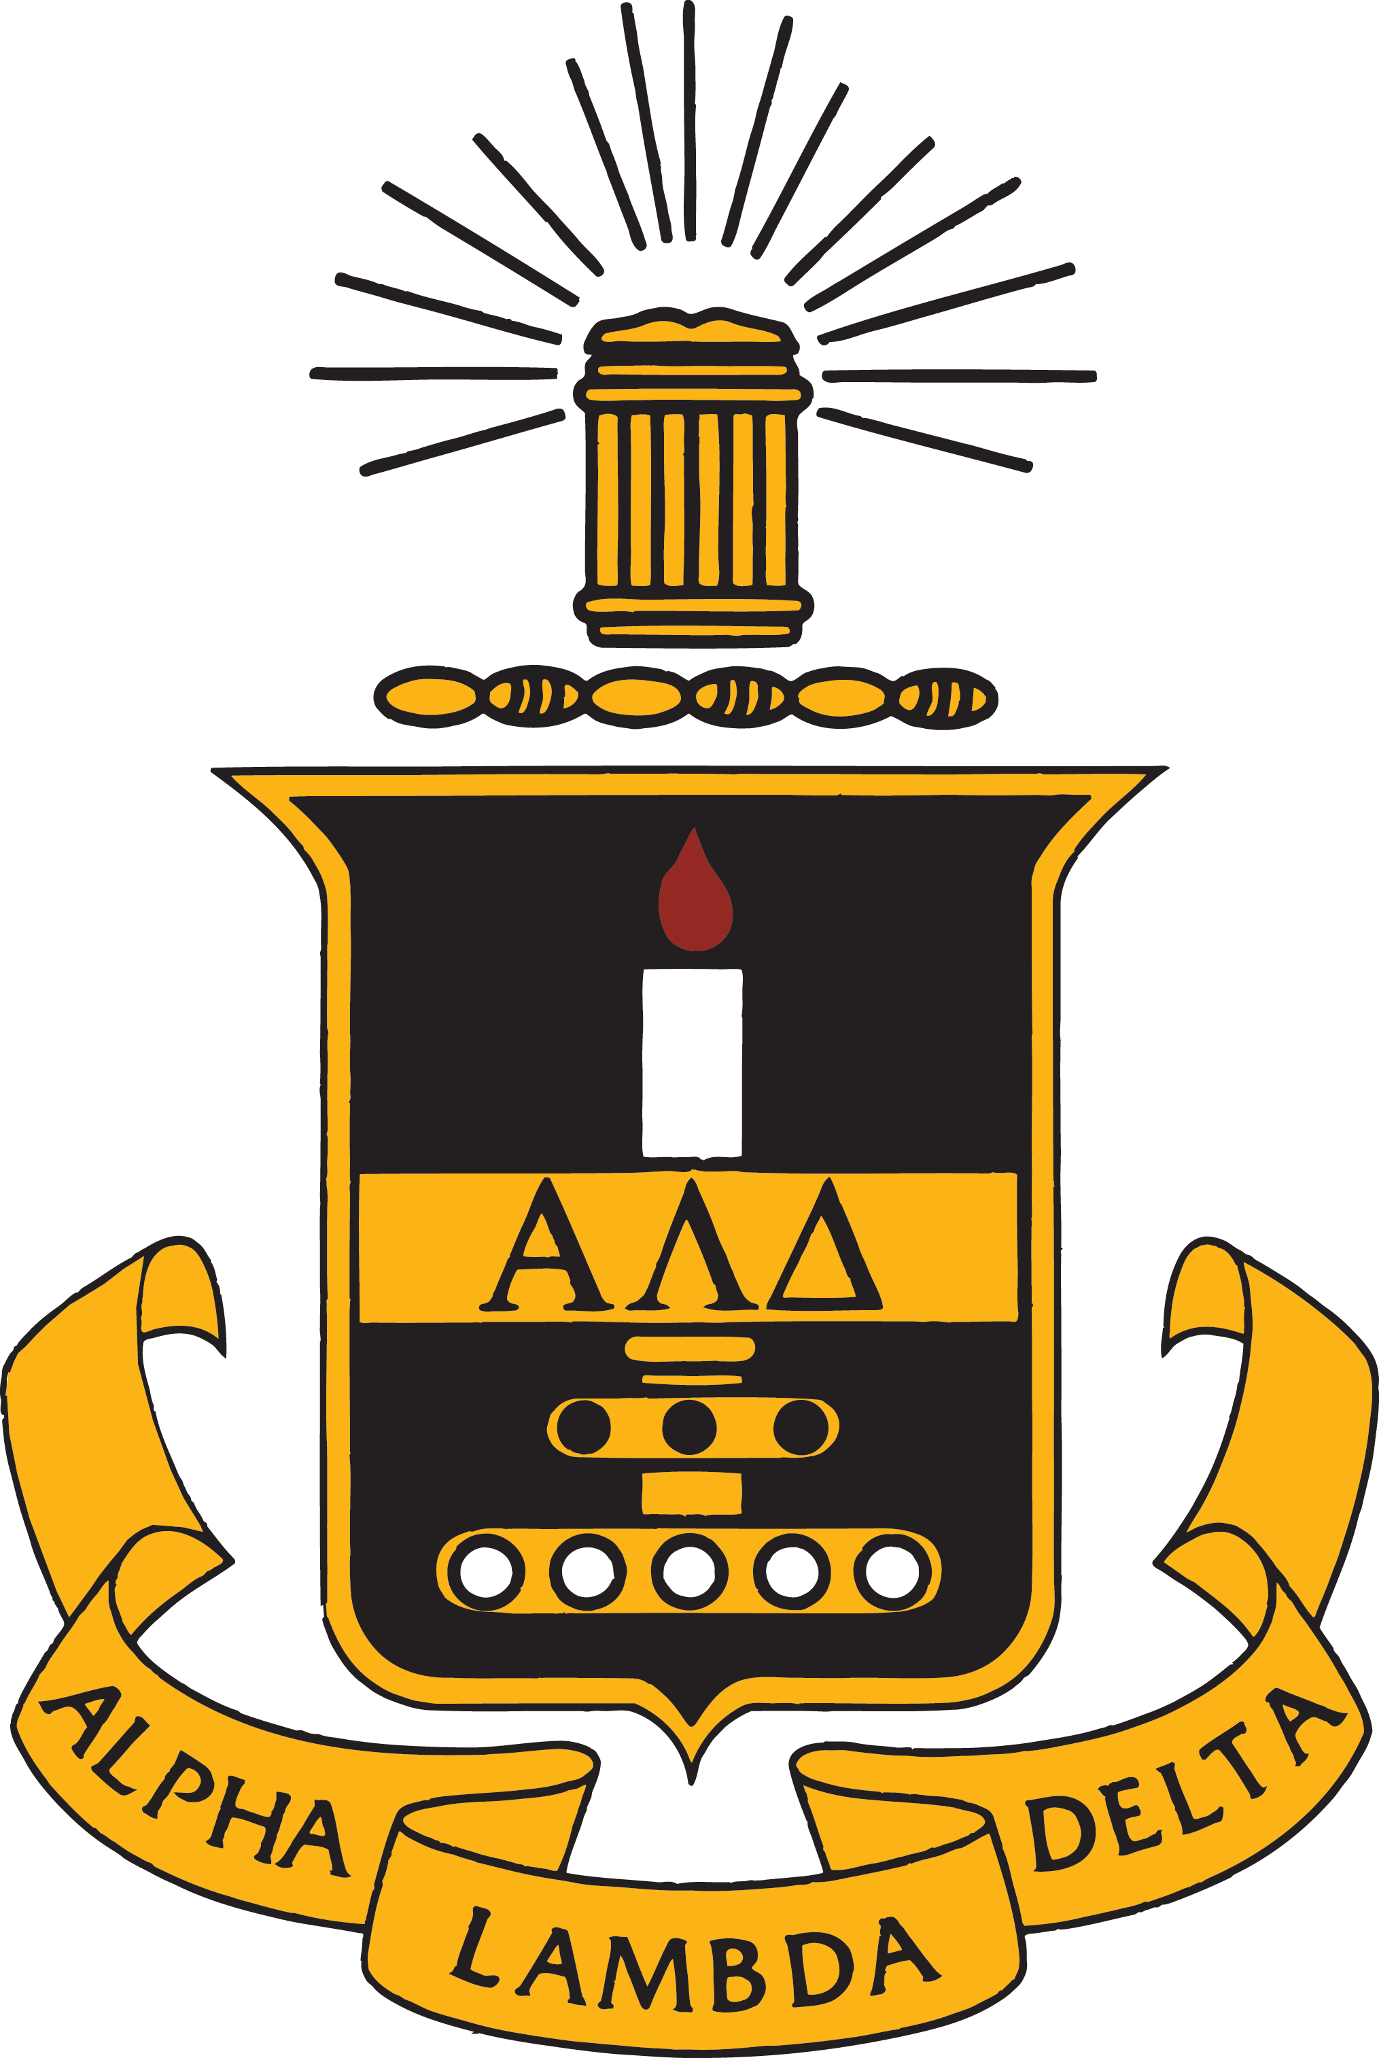The honor society soon became a national organization through the chartering of chapters at Purdue University in 1926, at DePauw University in 1927, at the University of Michigan in 1927, and at the University of Oklahoma in 1929. The first national convention was held in 1930 on the campus of the University of Illinois. Conventions were suspended during the depression years because of travel expenses. The third convention was held in 1938 at the University of Michigan. A decision was made at that convention to suspend holding a national convention and to invest those funds into establishing a graduate fellowship fund. The first fellowship was awarded to Louise Houssiere for graduate study at MIT in 1940.
The Association of College Honor Societies was organized in 1925 to consider matters of mutual concern to member organizations; Alpha Lambda Delta has been active in the Association since its admission to membership in 1939. In 1976, in response to Title IX, the Board of Directors voted for the Society to be co-educational. In 1981, the first two male members of the Board of Directors were installed.
Alpha Lambda Delta has continued to be innovative and responsive in recognizing academic excellence by providing Senior Certificates and the Maria Leonard Senior Book since 1939, offering a National Leadership Conference since 1978, recognizing outstanding chapters with the Order of the Torch Award since 1989, recognizing an Outstanding Advisor of the Year since 1990, and taking advantage of technology by posting a national web site in January of 1997.
DATE
TIME
LOCATION
Alpha Lambda Delta has continued to celebrate academic excellence among first-year students and has grown to over 280 chapters and has initiated over 1.2 million students. The Board of Directors which governs the organization has prudently invested the resources and gifts from local chapters, Board members, former fellowship recipients, and friends of the Society over the years so that the Perpetual Fellowship Fund can provide support for 50 undergraduate scholarships of $1,000-$6,000 each, 20 study-abroad scholarships of $1,000-$2,000, and 28 graduate fellowships from $2,000 to $7,000. The fellowships are named for significant people in the history of the Society.

CHAPTER INDUCTION

WELCOME

Name

Title

THE PLEDGE

INDUCTION OF HONORARY MEMBERS

SPEAKER

Name

Title

RECESSIONAL

PLEDGE

“I ACCEPT MEMBERSHIP…
INTO NATIONAL ALPHA LAMBDA DELTA …
UNDERSTANDING THAT IN DOING SO…
I ASSUME THE RESPONSIBILITY…
OF CONTINUING TO MAINTAIN…
ITS STANDARDS OF SERVICE…
OF DILIGENCE…
AND OF INTEGRITY.
I PLEDGE TO PROMOTE HIGH SCHOLARSHIP...
AND TO USE MY EDUCATION...
FOR THE BENEFIT OF MY COMMUNITY…
MY NATION…
AND THE WORLD IN WHICH WE LIVE."
INDUCTEES

Name  Name  Name  Name  Name  Name  Name  Name  Name  Name  Name  Name  Name  Name  Name  Name  Name  Name  Name  Name  Name  Name  Name  Name  Name  Name  Name  Name  Name  Name | Name  Name  Name  Name  Name  Name  Name  Name  Name  Name  Name  Name  Name  Name  Name  Name  Name  Name  Name  Name  Name  Name  Name  Name  Name  Name  Name  Name  Name  Name | Name  Name  Name  Name  Name  Name  Name  Name  Name  Name  Name  Name  Name  Name  Name  Name  Name  Name  Name  Name  Name  Name  Name  Name  Name  Name  Name  Name  Name  Name

